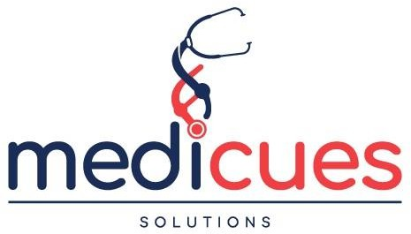

Company

Profile - 2026

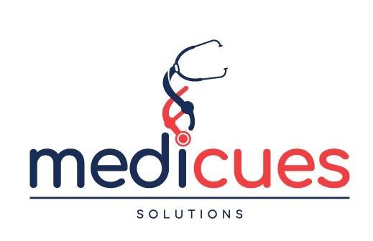

Company Details:
Legal Name: Medi Cues Solutions Limited Trading Name: Medi Cues Medical Solutions Established: 2024
Physical Location: Kilimanjaro City Arcade, Garden City Road, Nairobi,
Kenya
Postal Address: P.O. Box 1452 -00618, Ruaraka, Nairobi, Kenya
Contact: +254 116 263 263

Medi Cues Medical Solutions

About Us:
Medi Cues Solutions Limited is a trusted supplier of medical equipment, medical accessories, medical consumables, medical consultancy, equipment clinical application training, & medical equipment service. We work with the best global brands to deliver high quality equipment, accessories, spare parts, consumables and service to our customers since its inception in 2024.

Medi Cues Solutions is located at Kilimanjaro City Arcade, Garden Estate, Garden Estate Road, Nairobi, Kenya.

We offer a comprehensive range of medical equipment, accessories, spare parts, consumables and service that cater to all your hospital needs, ensuring that your facility runs smoothly.

We take pride in having served hundreds of satisfied customers with high- quality medical equipment, equipment accessories, hospital consumables, clinical application training, and equipment service.

Our team of highly skilled sales and clinical application specialists is dedicated to providing reliable, efficient and professional services that keep your facility running efficiently while you take care of your patients.

Medi Cues Medical Solutions

Our Services:
- Medical Equipment: Comprehensive range of medical equipment including Radiology, Cardiology, ICU, Mother & Child

- Medical Equipment Accessories: Printers, Probes, Cables….

- Medical Consumables: Thermal Papers, Ultrasound Gel, Electrodes, Gloves, Med Spread….

- Hospital Furniture & Fittings

- Equipment Installation

- Clinical Application Training

- Medical Consultancy

- Tender Specifications Consultancy

- Spare Parts Sourcing: We source a wide range of high-quality spare parts (both new and used) thereby offering a one stop solution for our customers.

Medi Cues Medical Solutions

Why Choose Us?

- High Quality Equipment, Accessories, Parts & Consumables: We provide high quality equipment, accessories, spare parts and consumables from globally recognized brands.
- Experienced Medical Professionals: Our team consists of highly skilled medical professionals who are committed to providing top-tier service to our customers.

- Customer-Centric Approach: We prioritize your satisfaction and ensure that all services are performed with precision and care.

- Affordable Prices: We offer competitive pricing without compromising on quality, providing excellent value for money.

Get In Touch:
For more information, please feel free to contact us via the contact information below:
  - Email: medicuesltd@gmail.com
  - Phone: +254 116 263 263

We look forward to serving you!

Medi Cues Medical Solutions

Know Our Clients:

At Medi Cues Solutions, we deeply value the customers who choose to service with us. Below are some clients who have agreed to share their details:
- Heartlink Cardio Centre, Nairobi, Kenya Mobile: +254 723 263923,
Email: finance.heartlinkcardio@gmail.com
- Cardio Services Support, Nairobi, Kenya Mobile: +254 722 747695
Email: drannemugeraknh@gmail.com
- Dr. Kamenwa Njenga Clinic, Nairobi, Kenya Mobile: +254 722 542956
Email: drknjenga2010@yahoo.com
- NCD Alliance-Kenya, Nairobi, Kenya Mobile: +254 722 127270
Email: catherine.munaji@ncdak.org
- Paedi-Hearts Cardiology Clinic, Nairobi, Kenya Mobile: +254 721 499717
Email: drekimani@gmail.com
- Division of Vector Borne & Neglected Tropical Diseases, Kampala, Uganda
Mobile: +256 753 255835
Email: bettiful@gmail.com
Medi Cues Medical Solutions

- Sciex Africa Limited, Dar es Salaam, Tanzania Mobile: +255 699 687772
Email: info@sciexafrica.com
- Betmed Medical Supplies Limited, Nairobi, Kenya Mobile: +254 734 980033
Email: info@betmedkenya.com

These customers and many others have contributed to our growth, and we appreciate their trust in us.

Medi Cues Medical Solutions

Our Shopping Cart: What We Offer:

Transducers

Accessories

Equipment

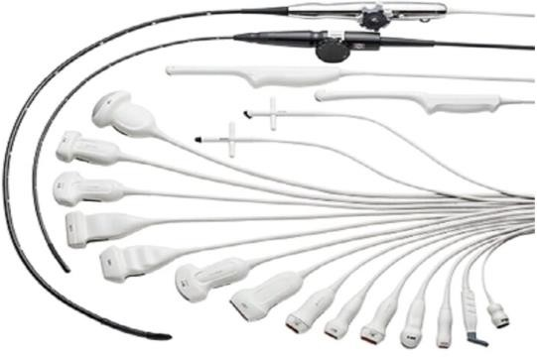

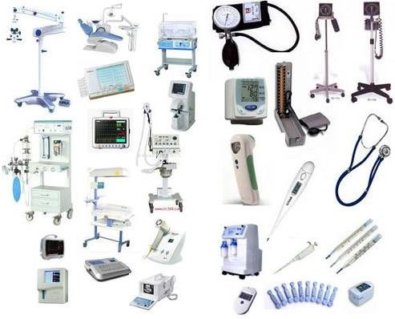

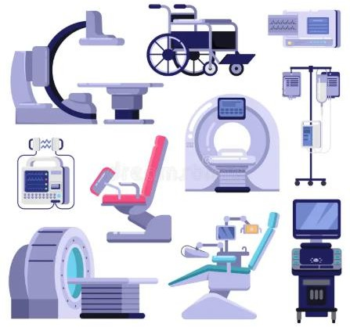

Medi Cues Medical Solutions
Consumables
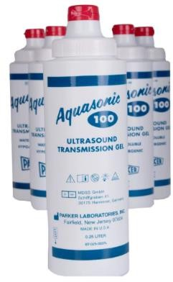

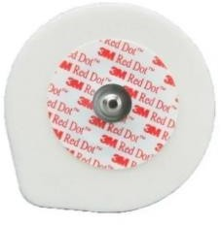

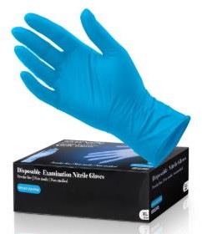

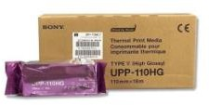





Medi Cues Medical Solutions

